**WT LAB**

**NAME - Aniket Chatterjee**

**Roll No - 2005783**

**Section - CSE26**

**LAB-4**

**DATE-10/02/22**

1. **Find the largest among 3 user entered nos. at the command prompt using Java.**

**CODE--**

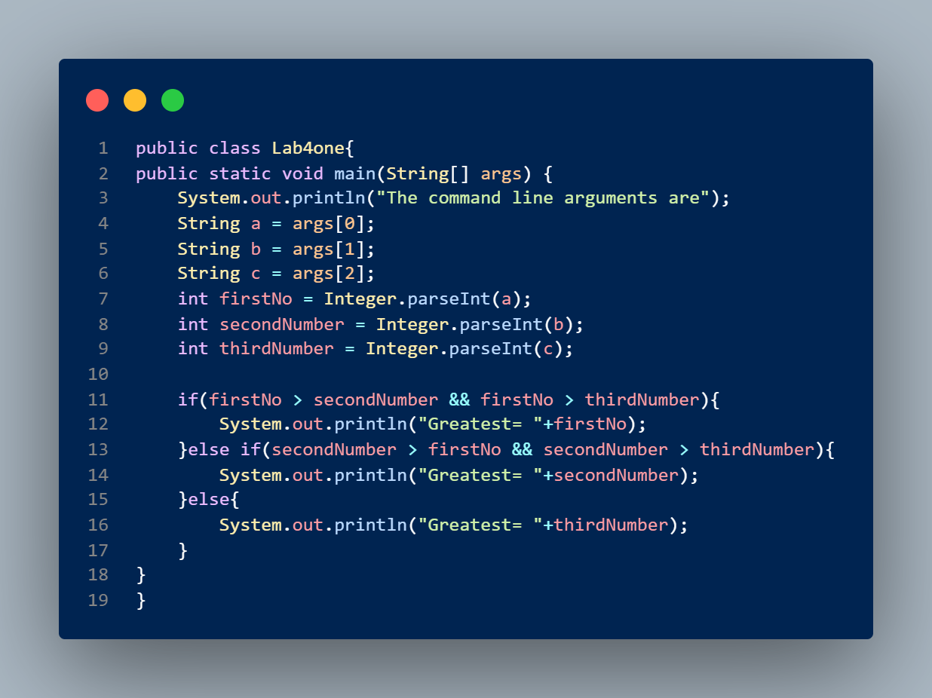

**OUTPUT--**

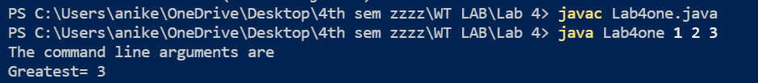

1. **Accept 10 numbers from command line and check how many of them are even and how many odd.**

**CODE--**

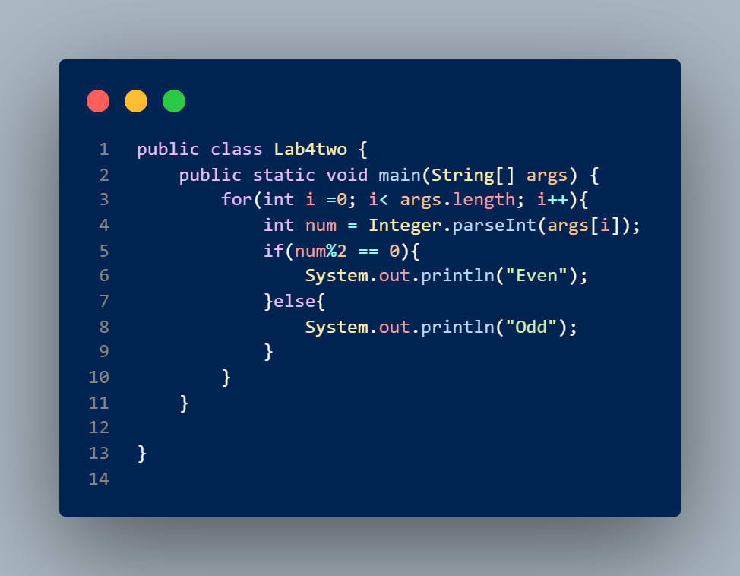

**OUTPUT--**

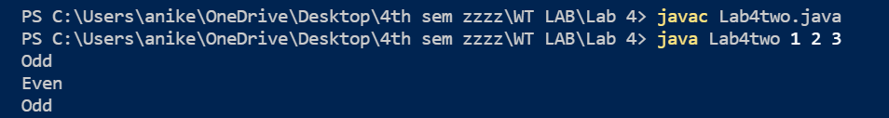

1. **Write a program to calculate area according to user input, whether it is circle, square or triangle (Menu Driven).**

**CODE--**

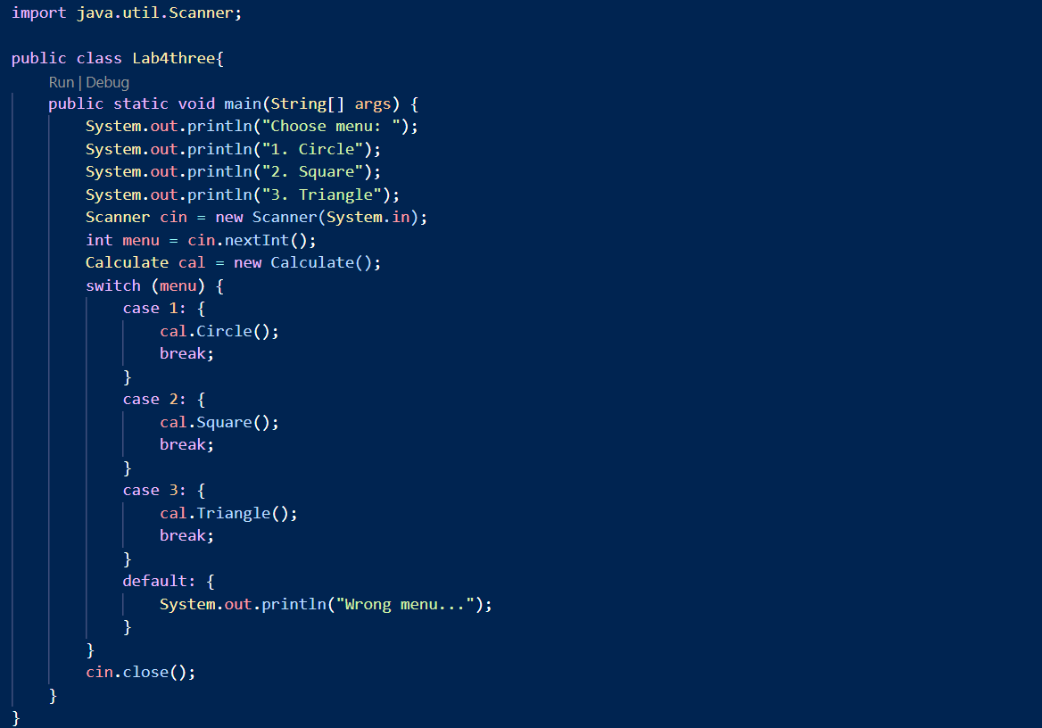

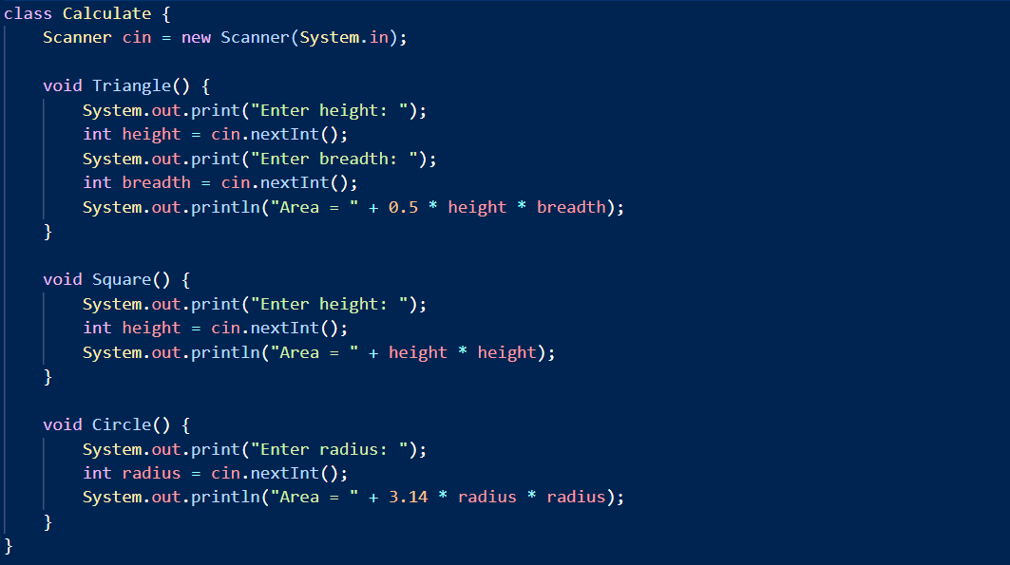

**OUTPUT--**

* **FOR circle**

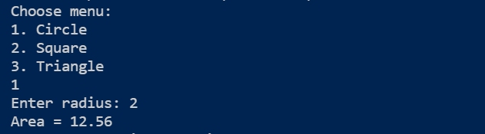

* For Triangle

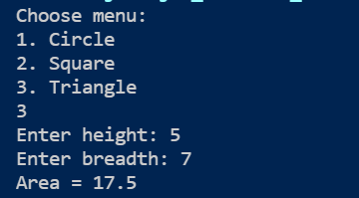

* **For Square**

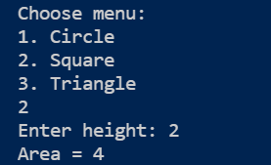

1. **Write a class file – box with three data members (length, width, height) and a method volume() . Also implement the application class Demo where an object of the box class is created with user entered dimensions and volume is printed.**

**CODE--**

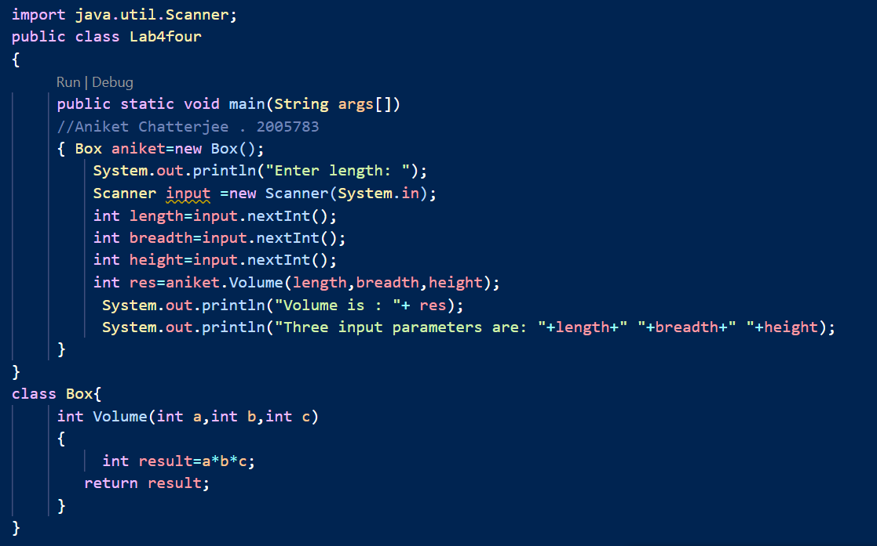

*OUTPUT IN THE NEXT SLIDE*

**OUTPUT--**

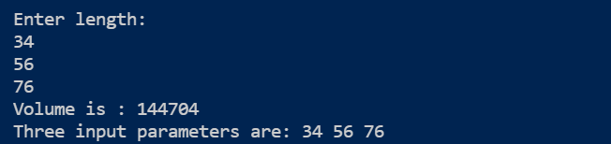

1. **Write a program which will overload the area () method and display the area of a circle, triangle and square as per user choice and user entered dimensions.**

**CODE--**

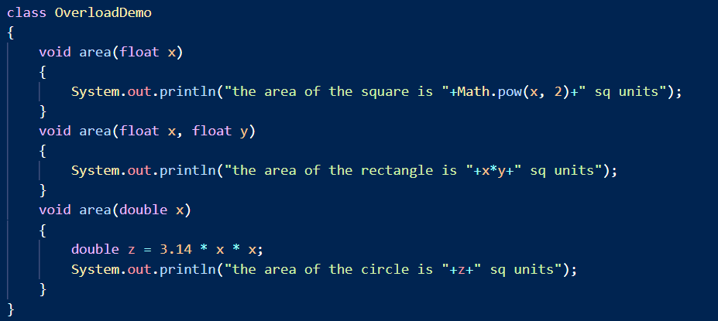

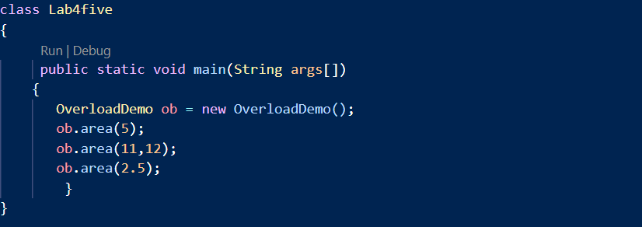

**OUTPUT--**

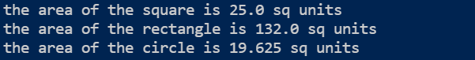

- 2005783